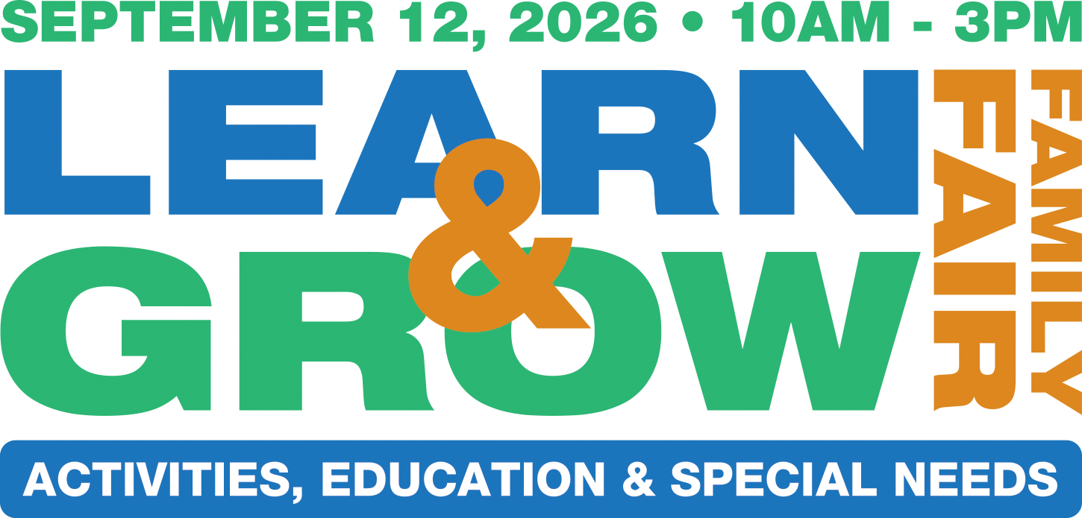

at The District in Tustin

Welcome Packet 2026



Welcome Learn & Grow Exhibitor!

Parenting Orange County Magazine is pleased to have you as part of the Learn & Grow Expo at The District at Tustin Legacy. We are excited about working with you and making it a successful event.

Enclosed in your Welcome Packet are the following:

• Exhibitor Checklist
Crucial dates and deadlines are included for event participation. Please
review this information and note dates that pertain to your participation level (i.e. bag inserts, sponsorship marketing materials, etc.).

• Event Logistics
Included are details to know before the event date, such as event hours,
set-up and teardown schedule, driving directions to the event, and important contact information.

• Effective Event Planning
This reference guide is included to give terrific tips to enhance your event
presence! Great tips on the power of social media and driving interest to your booth.

If you have any questions, please feel free to contact me at any time via phone or email. We are looking forward to seeing you on September 12 at The District at Tustin Legacy!

Sincerely,

Randall Tierney
Randall Tierney, Publisher
Randall.Tierney@ParentingOC.com
www.ParentingOC.com
Phone: 714.630.4510

Exhibitor Checklist

Please review the following deadlines and information:

• Bag Inserts
If you have purchased bag inserts – all 500 items must be received at the Parenting OC office by Tuesday, September 1, 2026 or they will not be included into the bags for distribution to guests at the event.

• Sponsorship Materials
If you have purchased a sponsorship, please contact your Account Executive for materials deadlines immediately.

Event Logistics

Date: Saturday, September 12, 2026

Set-Up Time: 8:00AM – 9:30AM (set-up time enforced)

Event Hours: 10:00AM – 3:00PM

If Exhibitor is not present in Event Space for the entirety of the Event,
Exhibitor will be fined $100 per occurrence.

Teardown: 3:00PM – 4:00PM

Location: The District at Tustin Legacy (Valet Parking Area), near the
Prego Restaurant
2409 Park Ave.
Tustin, CA 92782

Management: Parenting OC Magazine
305 N. Harbor Blvd., Suite 320
Fullerton, CA 92832
Office: 714.630.4510

Day Of Event Contact: Madison, Associate Publisher
714.630.4510

Effective Event Planning
Having a successful experience at an event requires social media
marketing and careful preparations prior to the event date!

Exhibiting at trade shows, expos, conventions, fairs, and other exhibitions provides you with a unique sales opportunity that can also help you in the generation of new leads, networking and publicity. You may have the opportunity to view your competition, as well. In short, what you may achieve at one event would take weeks or months to accomplish from home or in the office. And it may even save you money – according to the Center for Exhibit Industry Research, it costs 62% less to close a lead generated from attending an event than from a lead generated in the field. Accomplishing all of the above required careful planning, including setting clear objectives, creating an effective exhibition, and promoting your presence prior to the actual event date.

Setting Clear Objectives
To get the most out of the time, money and energy you invest in exhibiting at the event, it’s vital that you decide what your purpose is for being there. Set measurable goals. Everything that you do before, during, and after the event should be evaluated in terms of whether it contributes toward reaching them.

Possible goals for trade shows
• Spot Trends
• Gaining publicity
• Write Sales Orders
• Building your mailing list
• Generate leads for future sales
• Increasing your company’s visibility
• Building your rapport with current or potential customers

Staff Your Booth Adequately
You will need at least one person to take your place when you leave your reserved space to take a break or to take the opportunity to check out the competition if a competitor is on site. A good rule of thumb is to have two individuals present for every 100 square feet of exhibit space. Your staff should be well groomed, well trained, friendly and knowledgeable. Your staff should understand your goals and know their role in order to best reach these goals.

Focus Your Message
Choose a few key ideas that you would like to utilize at the event in order to “stay on message.” Design your graphics, pre-show promotion, literature and other event collateral around your message. “stay on message.” Design your graphics, pre-show, promotion, literature and other event collateral around your message.

Effective Event Planning (Cont.)

Creating an Effective Exhibit

Elate the Senses
Make sure guests can experience your product or service, if possible. Let them touch, see, feel, hear, or taste it.

Keep It Simple
Keep your booth graphics simple. One large graphic or photo can be seen from afar may have a greater impact than several small designs or photos. A single slogan that describes your business may say more than long blocks of text.

Gimmicks Work
Gimmicks and give-a-ways can also drive traffic to your booth. Hold a contest; provide a product demonstration; give candy to guests, provide any activity that will get the parents and children involved. Be sure that your method fits the company’s image and the sensibilities of your clients.

Promoting Your Presence
The best event planning will fail if guests do not know that you are present. The CEIR estimates that as many as three-quarters of event attendees know what exhibits they want to see before they arrive. Strong pre-event promotion will inform your customers and prospects about your exhibit.

The Power of Social Media
Let your customers know that you will be at the event through your social media resources: Twitter, Facebook, Tumblr, etc. The more your fans know about where you will be, the bigger the turnout you will receive! If you need marketing collateral, please let us know!

Work the Phones
Up to a month before the event date, it is helpful to call your customers and prospects to inform them about your location at the event.

Send Out Mailings
Focus on a few benefits from visiting your exhibit at the Event through a pre- show mailing.

Use the Press
In addition to the promotion that Parenting is doing for the Event, issue press releases to trade publications and local papers about your business being a part of the event. Your release should highlight a newsworthy story about your company. You will also want to prepare press kits for the show.

Event Parking Instructions

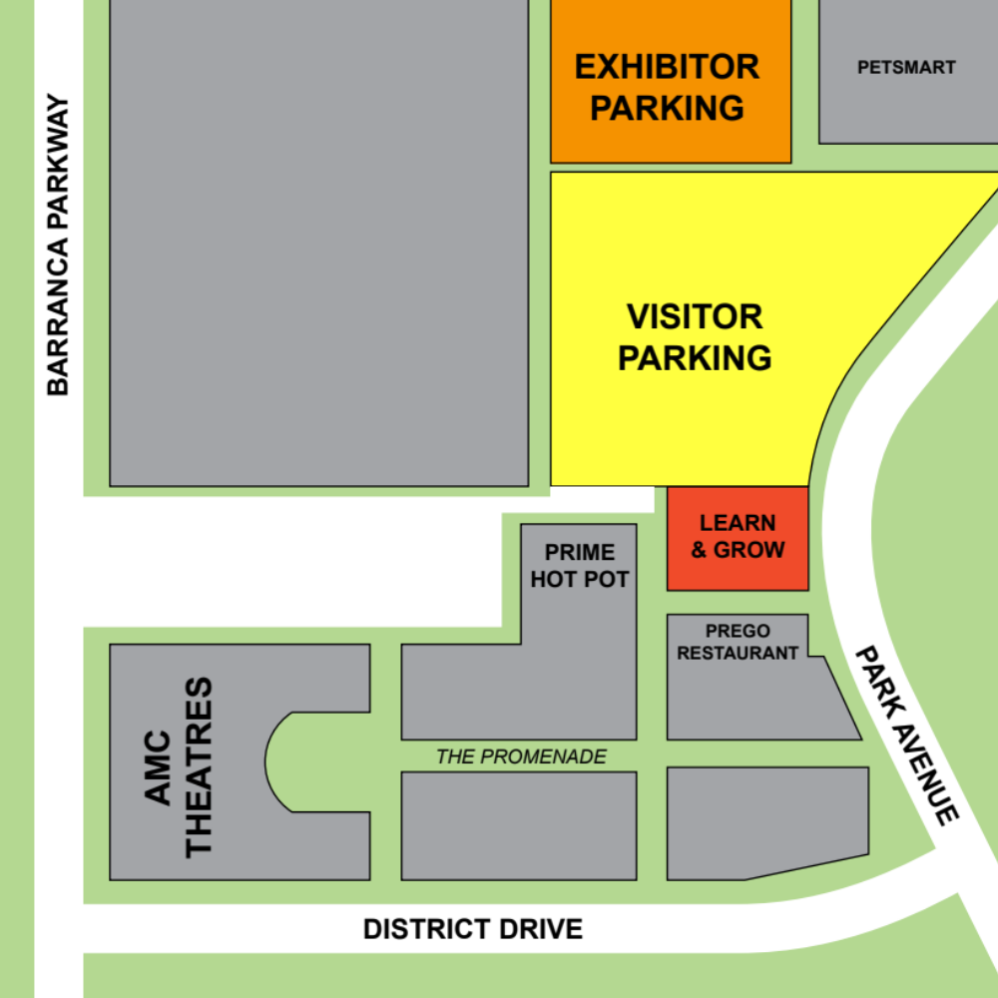

Map is subject to change.

- Exhibitors can park for setup between 8:00am to 9:30am in the Visitor Parking area.
- All exhibitors must move their car out of Visitor Parking NO LATER THAN 9:30AM! Please allow visitors to use the closer parking spots for easy access.
- Learn & Grow booths will be setup in “The District Valet” area.
- Similarly to setup, exhibitors can move their cars for breakdown NO EARLIER THAN 3PM.
- Tear down must be complete by 4pm, but in the event an exhibitor runs behind, please inform a Parenting OC Staff Member if you need additional time.

