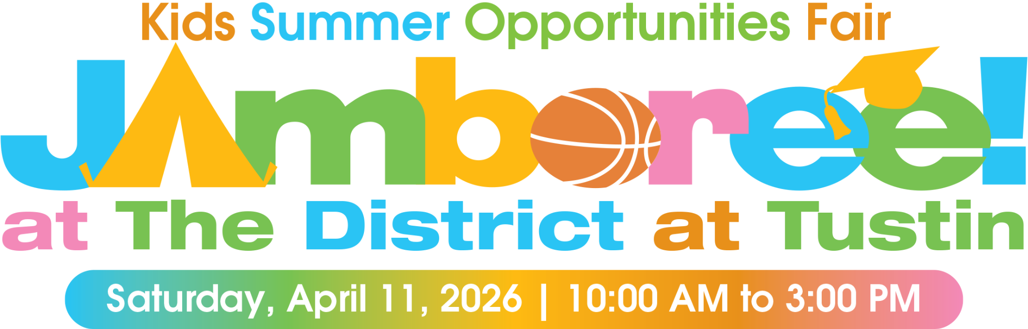 |   305 N. Harbor Blvd., Suite 320 | Fullerton, CA 92832  714-630-4510 Office | 714-492-8434 Fax

Space Reservation Form
EVENT DATE: April 11, 2026

AE:
Business Name: | Contact Name:
Business Address:
City, State, Zip:
Phone: | Fax:
Email Address: | Website:

Package Selection Information
Note: Rates reduced by 10% when client books space at the 2026 Learn & Grow Expo at the same time.

Co-Sponsor Exhibitor | $8,925 |  | Bag Logo | $185
Gold Exhibitor (Electricity +$100) | $3,040 |  | Bag Sponsor | $520
Silver Exhibitor (Electricity +$100) | $895 |  | Bag Insert + Bag Logo | $395
Bronze Exhibitor | $625 |  | Bag Insert + Bag Sponsor | $685
Check box if you are purchasing a Jamboree 2026 AND a Learn & Grow 2026 package | ☐ |  | Event Bag Insert | $315

Package: | Package Price:

Select THREE available spaces from the event map in order of preference.
All space reservations are completed in the order in which contracts are received.

Space 1: | Space 2: | Space 3:

Payment Information
Payment in full is required to reserve your space. We accept Visa, MasterCard and American Express.

Method of Payment:
Circle One: | Visa | MasterCard | American Express
Credit Card Number: |  |  | Exp. Date:
Name on Card: CVV (3-4 digit number on back of card):
Billing Address of Card:
Amount to be Charged:
Authorized Signature: |  |  | Date:

Customer Signature: | Date

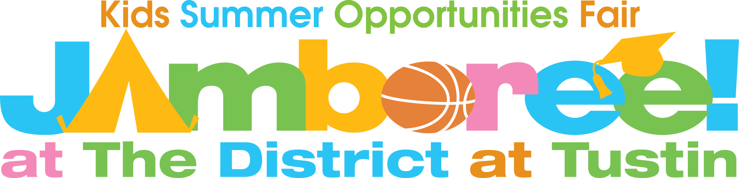

Exhibitor Terms & Conditions

This Agreement is made between Parenting Orange County Magazine and Exhibitor for Jamboree 2026. Agreement states the terms and conditions under which Exhibitor will appear at and/or make a presentation at Jamboree as follows:

EXHIBITOR INFORMATION
Business Name: | Contact Name:
Business Address:
City, State, Zip:
Phone: | Fax:
Email Address: | Website:

EVENT INFORMATION
Date: April 11, 2026
Hours: 10:00 a.m. – 3:00 p.m.
Location: The District at Tustin Legacy Valet (between Wagyu Factory Tustin and Prego Restaurant)

Costs and Expenses
All costs and expenses incurred by Exhibitor relating to the event in any manner, including but not limited to travel, hotel accommodations, and costs associated with the exhibit, are the sole responsibility of Exhibitor.

Assignment
To the extent that the obligations provided for in this Agreement require the personal attendance of the Exhibitor or its representative, Exhibitors rights, interests and obligations as provided herein may not be assigned. Exhibitor shall not voluntarily or by operation of law assign or otherwise transfer the obligations incurred on its part pursuant to the terms of this Agreement without the prior written consent of POC. Any attempted assignment or transfer of its obligation without such consent shall be wholly void. No assignment or transfer, even with the consent of POC, shall relieve Exhibitor of its obligations incurred pursuant to the terms of this Agreement.

No Warranties
Exhibitor acknowledges that POC makes no warranties as to the number of attendees at the Event, or to the amount of sales orders of any product offered by Exhibitor Presenter at the Event, if any.

Entire Agreement
This Agreement constitutes the entire Agreement of the parties on the subject matter of this Agreement and supersedes all prior agreements and understandings, either oral or in writing, relating to the Exhibitor’s attendance at the Event. There are no other understandings, promises, or inducements, oral or otherwise, contrary to the terms of this Agreement. No warranties, covenants or conditions, express or implied, whether by statute or otherwise, other than as set forth herein have been made by any party hereto. Any modification of this Agreement will be effective only if it is in writing, signed by the party to be charged.

General Provisions
(a) This Agreement shall be governed by the laws of the state of California. (b) If any action at law or in equity is necessary to enforce or interpret the terms of this Agreement, the prevailing party shall be entitled to reasonable attorney’s fees, costs, and necessary expenses. (c) All amendments to the Agreement must be in writing signed by both parties. (d) No waiver of any breach of the Agreement shall constitute a waiver of a subsequent breach, nor shall such waiver constitute a continuing waiver, and no waiver shall be binding unless executed in writing by the party making the waiver. (e) This Agreement shall inure to the benefit of and bind the successors and assigns of the parties hereto, and shall be binding on and inure to the benefit of their successors and assigns. (f) If any provision of this Agreement, or any portion of any provision, is held invalid or unenforceable by an agency or Court of competent jurisdiction, the remaining provisions shall nevertheless remain valid. (g) The parties waive any statutory or common-law rule of construction that ambiguities should be construed against the drafter of this Agreement. (h) Whenever in this Agreement the context so requires, the neuter gender shall be deemed to refer to and to include the masculine and the feminine, and the singular to refer to and include the plural, and vice versa. (I) The titles of the various articles of this Agreement are used for convenience of reference only and are not intended to and shall not in any way enlarge or diminish the obligations of the parties or affect the meaning or construction of this Agreement. (j) Management and Presenter hereby consent to the jurisdiction of the Superior Court of the State of California and the United States District Court for California for all purposes in connection with this Agreement. (k) All notices provided for by this Agreement shall be made in writing and shall be deemed delivered when (I) delivered personally, or (ii) deposited in the United States mail, first class and registered or certified, postage prepaid, and addressed to the business address for CEC set forth on this Agreement. (l) Any signature transmitted via facsimile is deemed an original signature. (m) This Agreement may be signed in counterparts, and upon execution by all parties shall constitute one original.

Exhibitor hereby agrees to observe and abide by the Terms, Conditions and Rules set forth herein and attached hereto, and by such additional Terms, Conditions and Rules made by Parenting Orange County on notice to Exhibitor from time to time for the efficient or safe operation of the Event.

Customer Signature: | Date

TERMS & CONDITIONS

- Agreement to All Terms, Conditions and Rules. Exhibitor agrees to observe and abide by the Terms, Conditions and Rules set forth hereafter and by such additional Terms, Conditions and Rules made by POC and Event (“Management”) on notice to Exhibitor from time to time, for the efficient and/or safe operation of the Event.
- Limitation of Liability and Indemnity. Neither Management nor Event Property nor any of their officers, agents, employees or other representatives shall be held liable for, and they are hereby expressly released from liability, for any damage, loss, harm or injury to the person or property of the Exhibitor or any of it’s officers, agents, employees, or other representatives, resulting from theft, fire, water, accident or any other cause. The Exhibitor shall indemnify, defend and protect Management and the Event Property against, and hold and save Management and the Event Property harmless from, any and all claims, demands, suits, liability, damages, loss, costs, attorney’s fees and expenses of whatever kind or nature, which result from, arise out of or are connected with any acts, or failures to act, or negligence of Exhibitor, or any of its officers, agents, employees or other representatives, including, but not limited to, claims of damage or loss resulting from breach of these Terms, Conditions, and Rules, and claims of damage or loss to any third party, resulting from any infringement of a copyright or patent or the unauthorized use of a trademark. In no event shall Management or the Event Property be liable for any consequential, indirect or special damages, whether foreseeable or unforeseeable, whether based upon lost goodwill, lost profits, loss of use of the Tabletop Space, or otherwise, and whether arising out of breach of any express or implied warranty, breach of contract, negligence, misrepresentation, strict liability in term, or otherwise, and whether based on this Agreement, any transaction performed or undertaken under or in connection with the Agreement, or otherwise. Exhibitor agrees that the liability of Management for damages, regardless of the form of action, shall in any event be limited to the aggregate fees paid by Exhibitor to Management under this Agreement, if any.
- Show Hours and Dates. Hours and dates for installing, showing and dismantling exhibits and/or merchandise shall be those specified by Management. Management reserves the right to change Event dates or location. Management will provide Exhibitor with proper notification in writing of any change in dates or location. Exhibitor reserves the right to cancel, without penalty, upon a reassignment of dates and location, without cause. Such cancellation must be made in writing by Exhibitor within 15 business days of notification of reassignment of dates or location.
- Assignment of Exhibit Space & Equipment. Exhibit space will be assigned by Management. Management reserves the right to modify the floor plan to accommodate space sales or relocate Exhibitors to avoid conflict, as necessary. In all instances, Management reserves the right to determine final placement of the Exhibitor. Such assignment is made for the date of this Show only and does not imply that the same or similar space will be held or offered for future expos or events. Management reserves the right to terminate this Agreement, close the Exhibitors exhibit and remove the Exhibitor’s property if Management determines in its sole discretion that Exhibitor is not eligible to participate in the Event or that Exhibitor’s product is not eligible to be displayed at the Event.
- Exhibitor and Management Responsibilities; Show Directory. Principal(s) and/or employee(s) of the Exhibitor must be present on the Event Property at all time during the Event. Management shall not be responsible for errors or omissions in the Official Program.
- Assignment. Exhibitor shall not assign to a third party, its right hereunder to the Event Space or any portion thereof without the written consent of Management, which consent Management may withhold in its sole discretion. If consent is given, Exhibitor shall assume full responsibility for the conduct of the assignee.
- Sale or Transfer of Exhibitor’s Business. In the event of the sale or transfer of a substantial portion of the assets of an Exhibitor’s business, or of the controlling stock interest in Exhibitor’s business, or in the event of a substantial change in the management of the Exhibitor, Management may, at its option, terminate this Agreement.
- Displays and Decorations. Merchandise, signs, decorations or display fixtures shall not be obstructing walk-through ways. No exhibit, merchandise, equipment, trunks, cases or packing materials shall be brought into or out of the Event Space during Event hours. No signs, advertising devices or merchandise shall be displayed outside the Event Space or project above or beyond the limits of the assigned Event Space.
- Set-Up, Exhibit & Tear Down Schedule. Exhibitor must comply with all schedules applicable to set-up times, exhibit times, and tear down times. If Exhibitor has not completed set-up by 9:30AM on the day of the Event, Exhibitor forfeits right to participate in the Event. If Exhibitor is not present in Event Space for the entirety of the Event, Exhibitor will be fined $100 per occurrence. If Exhibitor does not comply with teardown schedule, Exhibitor will be fined $50 for each 10 minutes exceeding teardown time.
- Fire Rules. Exhibitor shall not pack merchandise in paper, straw, excelsior or any other readily inflammable material. Exhibitor shall use no flammable decorations or covering for display fixtures, and all fabrics or other material used for decoration or covering shall be flameproof. If required by local laws or ordinances, Exhibitor shall have on hand in its Event Space, a notarized affidavit establishing that its display material has been treated during the past year by an approved chemical. All wiring devices and sockets shall be in good condition and meet the requirements of local law.
- Observance of Laws. Exhibitor shall abide by and observe all laws, rules, regulations and ordinances of any applicable government authority and all rules of the Event Property.
- Exhibitor Conduct. Exhibitor and its representatives shall not congregate or solicit trade in the aisles. The prior written consent of Management is required for the employment or use of any live model, demonstrator, solicitor or device for the mechanical reproduction of sound. Such employment or use shall be confined to the Exhibitor’s Space. Management, in its sole and absolute discretion, may withdraw its consent at any time, in which event Exhibitor shall terminate such activity forthwith. All promotional plans must be submitted to Management for approval in advance of the Show. Distribution of pamphlets, brochures or any advertising matter must be confined to the Exhibitor’s Space. Exhibitor shall refrain from any action that will distract buyers from attendance at the Event during open hours. The Event Space shall not be used for entertaining. Exhibitor shall not lead buyers from one exhibit space to another. Exhibitor shall not enter into another Exhibitor’s space without invitation or when unattended. Neither Exhibitor nor any of its representatives shall conduct themselves in a manner offensive to standards of decency or good taste.
- Photographs. No photographs of exhibit spaces or merchandise shall be taken without the prior written consent of Management or the Exhibitor involved.
- Playing or Reproduction of Music. Exhibitor shall not provide or permit the playing or reproduction of music in any form or at any time unless (a) if the music is copyrighted, Exhibitor shall in advance obtain, and provide a copy to Management of, a written license to perform said music at the Event from the owner of the copyright of said music and (b) whether the music is believed to be copyrighted or not, Exhibitor shall obtain in advance from Management a written consent to the providing of such music by Exhibitor. Exhibitor specifically agrees that in the absence of full compliance with (a) and (b) above, no music whatsoever, in any form, will be provided or permitted by it, and in the event of any copyright infringement issue arising with respect to the use by Exhibitor of all of the provisions of Paragraph 2 hereof will be applicable. Management shall have the power to make any reasonable settlement, without the consent or approval of Exhibitor, to resolve any dispute, which may arise between Management and anyone claiming to enforce a copyright. This settlement shall nevertheless be binding on Exhibitor insofar as holding Management harmless and indemnifying Management is concerned. Exhibitor expressly agrees that Management may, at Exhibitors’ expense, take any legal action, including summary action, appropriate to ensure compliance by Exhibitor with these provisions, including the obtaining of any injunction against Exhibitor.
- Americans with Disabilities Act. Exhibitor warrants and represents that it is in full compliance with the Americans with Disabilities Act and all regulations hereunder and agrees that is shall be responsible for the readily achievable removal of barriers relating to its exhibit or tabletop exhibit and the provision of auxiliary aids and services where necessary to ensure effective communication of Exhibitor’s product or services to disabled attendees at the Event.
- Closing of Exhibit. If Exhibitor or one of its subsidiaries or affiliates is on strike, resulting in picketing or similar type of demonstration in or near the Event Property, Management reserves the right to terminate this Agreement forthwith, close the exhibit and remove the Exhibitor’s property from the Event Space. Management shall be entitled to terminate this Agreement forthwith, close the exhibit and remove the Exhibitor’s property from the Event Space at any time for failure by Exhibitor or its duly authorized assignee or any of its officers, agents, employees or other representatives to perform, meet or observe any Term, Condition or Rule set forth herein, and such Exhibitor shall not be entitled to a refund of any payments, if any.
- Future Shows. In addition to Management’s right to terminate this Agreement, close the exhibit and remove the Exhibitor’s property as provided for in Paragraph 17 hereof, Management, in its sole judgment, may refuse to consider Exhibitor for participation in future events with which Management is involved if Exhibitor violates or fails to abide by all Terms, Conditions and Rules set forth herein.
- Inability to Hold Show. If, because of war, fire, strike, exhibit facility construction or renovation project, logistical problems, government regulation, public catastrophe, terrorist attack, act of God or the public enemy or other cause beyond the control of Management, the Event or any part thereof is prevented from being held, is cancelled by Management or the Event Property or any part thereof becomes unavailable, Management shall have no liability to Exhibitor, except that Management, in its sole discretion, shall determine and refund to the Exhibitor its proportionate share of the balance of the aggregate exhibit fees received which remains after deducting expenses incurred by Management and reasonable compensation to Management, but in no case shall the amount of the refund to Exhibitor exceed the amount of the exhibit space fee paid, if any.

Exhibitor Products and Services

Please list all products and services that are to be displayed or sold at the Event. Also note if you have any electrical needs, as well.

